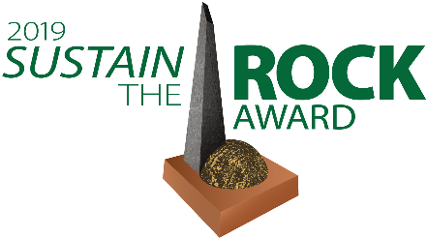 2019 Sustain the Rock Award
Nomination Form
Deadline: February 20th, 2019
The Sustain the Rock Award recognizes businesses, non-profits, individuals, and departments or employees of the City of Little Rock who have made significant contributions to a more sustainable Little Rock. They contribute to a more sustainable city by embracing and promoting an approach to business and daily living that balances environmental responsibility, economic prosperity, and community equity.
Qualifications: Nominees must live or have their principle place of business in the City of Little Rock. Self-nominations are accepted. Past winners do not qualify. To see a list of past winners view our winners list.
Selection Process: The Sustainability Commission serves as the selection committee. Winners will be notified the first week of March and will be invited to accept their award on March 29th at the Ninth Annual Sustainability Summit.
Nomination Procedure: Fill out this nomination form and submit it to the City of Little Rock Sustainability Office by February 20th. (Submission info at end of form.)
Nomination Form

Nominee Name: ______________________________________________________
Nominee Phone Number: ___________________
Nominee Email: __________________________
Nominee Category:
❑ Small Business (less than 10 employees) ❑ Medium Business (10 to 50 employees) ❑ Large Business (50+ employees) ❑ Restaurant
❑ Non-Profit Organization/Volunteer Group ❑ Individual
❑ Educator ❑ City Department or Employee

Nomination Narrative: In the space below describe the nominee, their achievements in sustainability, and the reasons the nominee should be recognized. Please keep the narrative to one page, not including any relevant attached supporting documentation.

________________________________________________________________________
Nominator (Your) Name:
Nominator (Your) Contact (email or phone):
Submit your form via email, fax, or mail. If submitting my mail, the nomination form must be received (not postmarked) by February 20th. If you have any questions or concerns please call the Sustainability Educator at 501-371-4586.

Email: tmullins@littlerock.gov

Fax:
501-371-4843

Mail:
Faith Mullins
701 W. Markham Street
Little Rock, AR 72201

