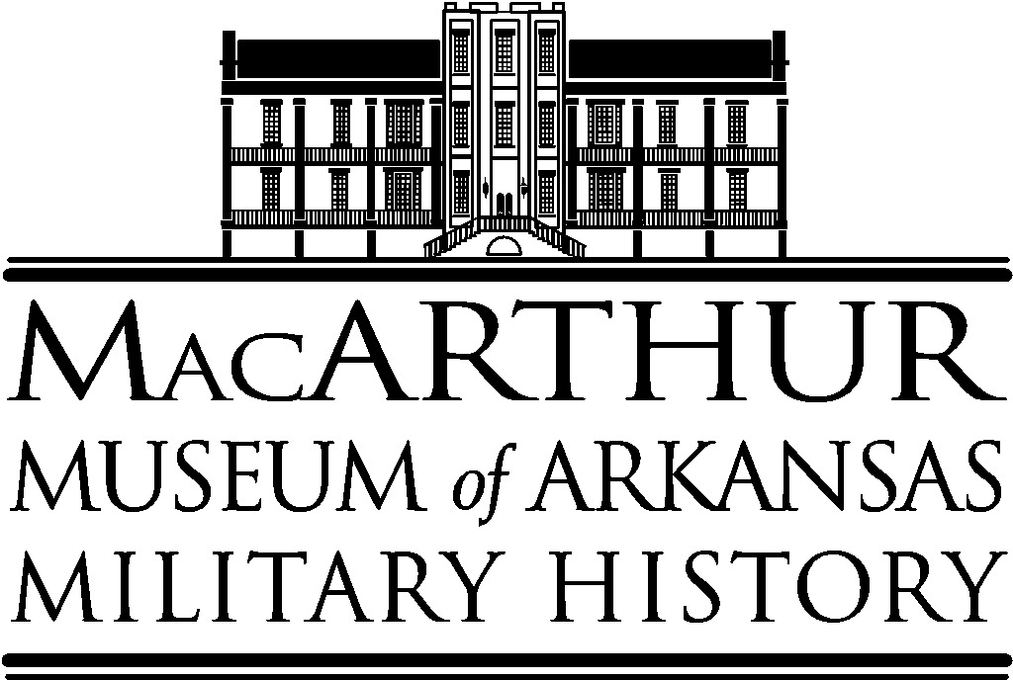

BUILDING USE POLICY

PROCEDURES

- The MacArthur Museum of Arkansas Military History may be used for a political event, to sell a product, to announce a fund-raising activity or to hold a fund-raising event provided the user pays the appropriate fee for such usage. *

- FEES. A fee will be charged to all users of the facility. The attached “Fee Schedule” gives the length of time allotted for each type of function, including set-up and clean-up. Interested parties should visit the building to determine if available space will accommodate an event. All fees are due at least one week before the function. If persons related to a function remain in the building longer than the amount of time for which the building is reserved, the User will be charged $50 for each additional half-hour the building is occupied. It is the User’s responsibility to ensure that all persons related to the function depart within the allotted time. No event may exceed five hours, including set-up and clean-up time.

- Deposits. A non-refundable deposit of $150 is required to reserve the building for an evening function.

- Cancellation Policy. All requests for cancellation must be made in writing to the museum director. At least three weeks written notification of cancellation is required or the full rate will be charged.

- User Responsibility. (1) The user is responsible for and will assume the cost for any damages to the building and its contents during his or her function. This responsibility extends to all guests and to all individuals and/or firms employed by the user. Replacement or repair costs will be determined by the MMAMH and paid by the user. (2) The user agrees to remain on-site during the clean-up and to do a walk-through of the facilities with a museum representative to ensure all provisions of the policy have been followed and that the rooms have been returned to proper layout.

- Catering. All food and drink catering must be approved by the museum. A copy of the “Procedures and Policies for Caterers” must be provided to prospective caterers by the person or group making the reservation. Caterers will be restricted to areas designated by staff. Caterers are required to do their own set-up and clean-up immediately after the function. Any food and beverages remaining after the close of a function become the museum’s property and will be discarded. All trash MUST be removed from the building and deposited in the dumpster. The user is responsible for making the caterer aware of these conditions.

- Alcoholic Beverages. Wine, champagne, and beer in cans or bottles may be served to guests at the museum for no more than two hours by caterers or designated servers. Keg beer is not permitted. Service of hard liquor must be approved prior to a function by the appropriate museum staff. All liquor service must be in full compliance with all laws and regulations governing the use of alcoholic beverages. The museum reserves the right to terminate the service of alcoholic beverages.

- Smoking. Smoking is prohibited inside the building and on park grounds by City Ordinance.

- Entertainment. Small musical ensembles are permitted including electrical keyboard instruments. The piano may NOT be used for events. Due to the age of the floors, dancing will not be allowed.
- Decorations and Flowers. No alterations of the galleries, walls, or any part of the building or exhibits are permitted in any way. Wire clips, staples, nails, and adhesives are forbidden because of the damage they will do to historic materials. Decorations may be fastened only in a manner that does not in any way cause damage. Only dripless, slow-burning candles may be used. Candles will be snuffed by staff if they begin dripping. Rice is not permitted. User is responsible for removing decorations and flowers from the premises at the end of a function. Decorations or flowers left after the close of a function become the museum’s property and will be discarded and a fee charged for removal.

- Delivery & Pick-up of Rentals. Items rented for use at a function should be delivered and picked up the day of the function; rentals should not be left in the museum overnight. Arrangements must be made with staff for delivery or pick-up of rentals outside the hours reserved for a function.

- Movement of Furnishings. With the approval and supervision of staff, some furnishings may be rearranged. Anything that is moved must be returned to its original place at the end of the function. The piano may not be removed from the room. The user must provide chairs, tables, cloths, and any other supplies necessary for the function. The museum may grant permission for the use of museum tables and chairs upon the discretion of the director.

- Grounds Use. All requests for use of the grounds should be directed to the Little Rock Parks and Recreation Department. No vehicles may be driven or parked on the grounds.

- Staff. The staff’s primary purpose at a function is to ensure the safety of the building, its collection, and programs and to be certain that the user adheres to the MMAMH procedures and policies. It is not staff’s role to complete tasks related to the set-up and clean-up of a function.

- Parking. Parking is available in the circular drive in front of the museum and in the parking lots directly to the east of the building.

- Non-Discrimination Policy. The MacArthur Museum of Arkansas Military History shall not discriminate against vendors because of the race, color, creed, religion, sex, national origin, age, disability, marital status, sexual orientation, gender identity, genetic information, political opinions or affiliation of the vendors' owners.
- Employees of the MacArthur Museum of Arkansas Military History, in providing city services to the public and public accommodations, shall not discriminate because of race, color, creed, religion, sex, national origin, age, disability, marital status, sexual orientation, gender identity, genetic information, political opinions or affiliation.
- All contracts providing goods and services to the City of Little Rock shall contain a clause stating that the contracting party shall not discriminate on the basis of race, color, creed, religion, sex, national origin, age, disability, marital status, sexual orientation, gender identity, or genetic information. All bid and proposal requests for such contracts from the City of Little Rock shall include notification of such a clause and the requirement that it be agreed to and followed.

RESERVATION AGREEMENT

The MacArthur Museum of Arkansas Military History appreciates your decision to hold your function at the historic Tower Building. A non-refundable deposit of $150 is required to reserve the building for your use. Unless the deposit and a completed "Reservation Agreement" are received by the museum within 10 days of the date it is mailed from the museum, the date and time of a function will not be reserved. The MMAMH retains the right to terminate the reservation agreement at any time if all conditions are not met. The MMAMH also reserves the right to decline reservation agreements that conflict with its mission and goals or would in any way misrepresent the museum.

The $150 deposit will be applied against the balance due the day of the function.

Make checks payable to the MacArthur Museum of Arkansas Military History and mail to the address on this letterhead.

Reservation made for: ______________________________________________________________________

Mailing Address: ______________________________________________________________________

City/State: ____________________________________________ Zip: ____________________

Telephone: Hm: _____________________________ Wk: __________________________

Type of function: ______________________________________________________________________

Date of function: _____/_____/_____ From: _____________ to _______________

Ceremony Time: __________ Caterer: ___________________ Guests: ___________

Anticipated fee: $____________ (See Fee Schedule) Amount Enclosed: __________

I have received and read the MacArthur Museum of Arkansas Military History Procedures and Policies, and agree to abide by, and be bound by, these conditions. I agree to use a caterer approved by the museum. Because of the historic character of the Tower Building, I understand that the violation of any of these rules by me or my guests is cause for eviction from the premises.

Signed: _____________________________________________ Date: _____/_____/_____

Deposit/Reservation Accepted: ___________________________ Date: _____/_____/_____
Museum Representative

PROCEDURES AND POLICIES FOR CATERERS

It is understood by and between the MacArthur Museum of Arkansas Military History, the person or group using the facility, and the caterer that is in charge of the event which the user has contracted to handle. In accordance with this agreement, the caterer and user agree to:

- Keep dishes, cups, etc. bused from the tables and other articles of furniture during the event to avoid damage to the furnishings of the museum.

- Retain bartenders or servers (if applicable) and oversee their duty. The bartender will serve all drinks, and guests will not remove bottles from the serving area. All alcoholic beverages will be under the control of the caterer.

- The caterer will see that all glasses, plates, silverware, serving pieces, etc. are cleared before he/she leaves the premises. All trash must be taken to outside carts.

- The caterer will see that all crumbs and debris are removed from the floors, rugs and porches. If the kitchen is used, it will be cleaned as well.

- The caterer will, in general, leave the premises in the condition in which it was found.

- It is understood that the MMAMH is available for no longer than five hours for any event. Should the caterer not be able to complete his/her responsibilities within the allotted time, the user will be responsible for payment of any overage. Generally, at least one hour at the beginning and the end of the rental function should be reserved for set-up and clean-up time.

- The caterer agrees to carry liability insurance on all workers brought into the building.

- Any decorations, food or beverage must be removed by the end of the rental function. Items left by the caterer become the property of the MMAMH and will be disposed of.

I have read the above conditions and agree to abide by them at all functions at the MacArthur Museum of Arkansas Military History.

Date: ______________________________ _____________________________________________
Name of User (Person renting the MMAMH)

FEE SCHEDULE

Type of Function Rental Fee Maximum Time Allowed (Including Set-up & Clean-up)

Evening Reception/Dinner/Meeting $1,000* five hours

Political Events $1,000 five hours

Daytime Luncheon/Meeting $75/hour two hour minimum/four hour maximum**

Rental of the second floor does not include access to the balconies.

*Fees include rental of the building.

**Events must occur during the Museum's regular business hours.

Revised: July 2015
Revised: September 2020

