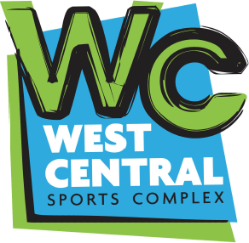 Registration Form
Sport - Please Circle: Flag football; Football Tee-Ball; Baseball Softball Pitching Machine Basketball
Child’s Name:___________________________________Age:____
Parent Name:____________________________________________________________
Address_______________________________City_________Zip_______
Parent’s contact #:_____________________________________
Emergency Contact person Name_________________________ #______________
Please circle the size indicated for the child,
Pants/shorts XS, S, M, L, XL
Shirt: XS, S, M, L, XL
Amount Paid_____________Form of payment, please circle: Cash, Check, Money Order
Parental Consent
As parent/guardian of the above named player, I hereby agree not to hold the WCSC or any of its staff or volunteers liable for any injuries that may occur to my/our child while participating in any activities in the concerned sport in which the child is participating. I accept full responsibility for any and all medical expenses that may occur due to injury to my child. By signing the Parental Consent form, I fully accept these conditions and authorize my child to participate in the concerned sport administered by WCSC. Also, you agree that the West Central Sports Complex can use pictures of your child in promotional material for the park and its programs.
Parent/Guardian Name____________________________________________Date

