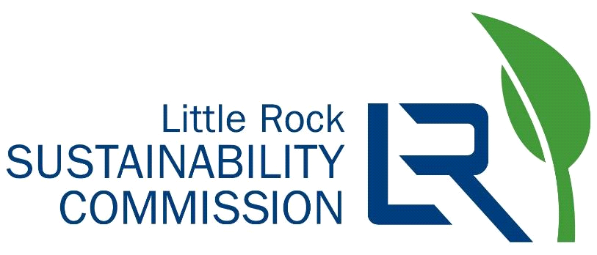

Little Rock Sustainability Commission
Agenda for February 23, 2022, at 3:00 pm
Virtual

- Welcome, Introductions, Roll Call
2022 Commissioners:
Jan Baker  Kate Fletcher  Rachel Furman  Scott Hamilton  Andrew Jester – Vice Chair  Uta Meyer | Anna Morshedi  Ann Owen  Wesley Prewett  Sheridan Richards  Karen Zuccardi – Chair
- Approve Minutes of the Previous Meeting
- Citizen Input (5 minutes)
- City Director & Liaison Input
- LRSO Report
- LRSC General Report
  - New Business
  - Commissioners' terms and advertising open positions (explanation from city attorney)
  - Chair and Vice-chair elections (after new commissioners are appointed and all seats filled)
  - Process Tree
  - Internal Goals: 2022
- Working Team updates:
  - Built Environment
    - Current projects
    - New business
  - Natural Environment
    - Current projects
    - New business
  - ECO (Education & Community Outreach)
    - Current projects
    - New business
- Next three meetings: March 23rd, April 27th, May 25th

