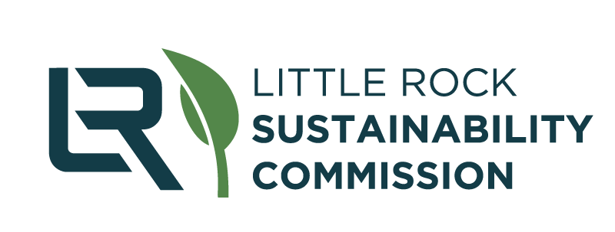
Little Rock Sustainability Commission
Agenda for August 24, 2022, at 3:00 pm
Willie L. Hinton Resource Center, Auditorium

SHARED GOOGLE DRIVE FOLDER
(For Commissioner Use Only)

- Welcome, Introductions, Roll Call
2022 Commissioners:
Jan Baker  Larissa Barry  Kate Fletcher  Rachel Furman  Scott Hamilton  Andrew Jester  Rachel Cotner | Uta Meyer  Anna Morshedi – Vice Chair  Ann Owen  Wesley Prewett – Chair  Sheridan Richards  Jeremy Stehle  Andrew Vogler
- Approve Minutes of the Previous Meeting
  - Link to view last month’s minutes.
- Special Guest: Jon Honeywell, City of Little Rock Director of Public Works (30 minutes)
  - Overview of the Public Works Dept.
  - Q&A
- Citizen Input
- City Director & Liaison Input (15-20 minutes)
  - Director Peck comments/updates
    - eScooter Revenue
    - 15th Appointment
  - James Owen comments/updates
    - Solar RFP Update
    - Policy Review Update
      - One-pager Template
- CONSENT AGENDA [motion]
- LRSC General Report
  - Comments on new meeting format (consent agenda, speaker/special guest)
  - Ideas for speakers
  - Ideas for next field trip
  - Jobs of Tomorrow update (Rachel Furman)
  - Resolution for Sustainability
    - Board Presentation in September
- LRSO Report
  - Cooperative Task List Updated
    - Cooperative Sign Up
  - 1 minute radio spots on KUAR
    - Interest?
  - Website updates, including GRCP, GG4E, Clean Energy and more
  - Email went out with GRCP update on 8/10/22
  - Next Green Events - Volunteer on “Cooperative Sign Up” above
    - Great Arkansas Clean Up, Sept. 10th
    - Zoo Brew, Sept. 15th
    - Family Day with Arkansas PBS, Nov. 5th
    - Harvestfest, Oct. 22nd
    - LITfest, Oct 7-9 (?)
  - Future updates - what does LRSC what to hear from Office?

Working Team updates:

  - Built Environment
    - Meets 3rd Tuesdays @ 4pm on Zoom
      - Co-chairs: Scott Hamilton, Kate Fletcher
    - Link to view last month’s minutes
  - Natural Environment
    - Meets 2nd Wednesdays @ 4pm on Zoom
      - Co-chairs: Rachel Furman, Jeremy Stehle
    - Link to view last month’s minutes
  - ECO (Education & Community Outreach)
    - Newsletter going out in August and November
    - Contact Anna or Brittany to be involved with content

- New Business
- Next three meetings: September 28, October 26, December 7

