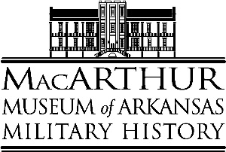
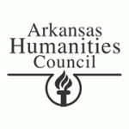
The Arkansas Humanities Council
In Partnership With The
MacArthur Museum of Arkansas Military History

Helen T. Leigh Museum Field Trip Grant, 2019-2020

The MacArthur Museum of Arkansas Military History offers travel grants to help students visit the museum for interactive programs that enhance the teaching of World War I and II, as well as learn about the historic Arsenal Building and Civil War Arkansas. The grant offers up to $500 to public schools for field trips to 3rd – 12th grade students, as well as public community colleges in Arkansas.
First Call: American Posters of World War I
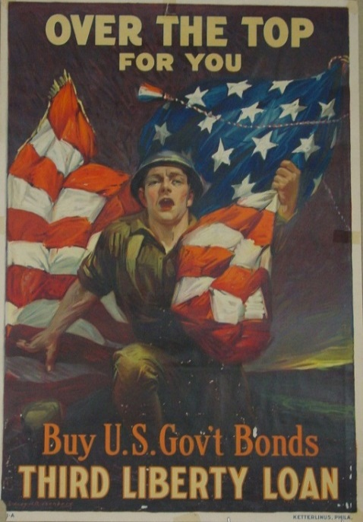
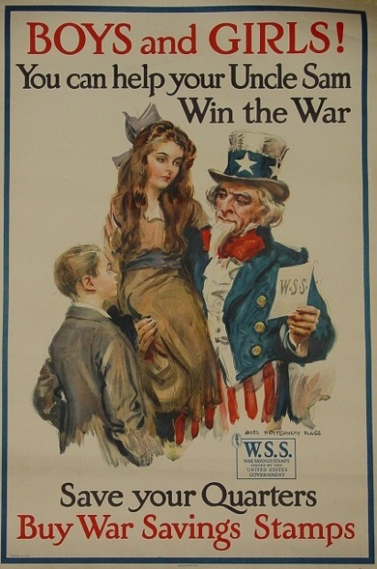
MacArthur Museum of Arkansas Military History invites students and teachers to experience the exhibit First Call: American Posters of World War I. This colorful exhibit highlights the creation of numerous war posters from the United States. The posters offer a unique perspective of World War I through artists’ renditions of frontlines and home-front scenes to spur Americans to support the war effort. Posters for the United War Work Campaign, the American Red Cross, and most notably the Liberty and Victory Loan campaigns were successful in raising funds for the war and promoted an outpouring of public support for the cause.

The educational program examines how propaganda impacted and defined cultural perceptions through the use of primary sources. It includes a historical introduction to wartime propaganda, poster analysis, viewing and discussion of film propaganda, and a poster making activity.

The Little Rock Arsenal

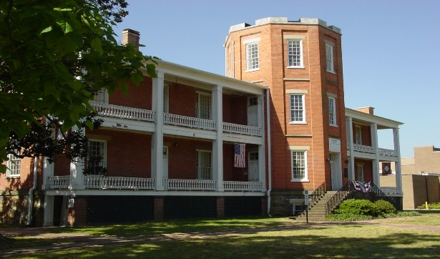
“We are a frontier people exposed to savage invasions and are often in pressing need of assistance and protection which only the federal government can provide,” wrote Arkansas Governor James Conway to the United States War Department in 1836. Four years later one of Little Rock’s oldest buildings was completed. Explore the rich military history of the Arsenal Building, recognized as a National Historic Landmark and used as a military post from 1840 through 1892. Students learn what makes a building historic, how the Arsenal Building was used during and after the Civil War and what it was like being a soldier during that conflict. Examine the famous and not so famous people and events that shaped the building’s history through video clips and lecture.
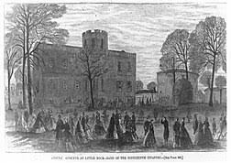

Civil War-Little Rock Arsenal Crisis

The first shots of the Civil War were almost fired at the Little Rock Arsenal. In February, 1861 a group of armed militia sympatric to the newly formed Confederacy arrived from the southern and eastern part of the state demanding that Captain James Totten of the 2nd U.S. Artillery turn the arsenal over to them so that they could give the weapons to the Confederate States of America. This caused grave concern to the citizens of Little Rock as well as Governor Henry Rector since Arkansas was a state deeply divided over the question of secession and was still a state belonging to the United States. Only compromise between all parties involved prevented bloodshed and the first shots of the Civil War being fired in the state’s capital.
This program explores what led to the Arsenal Crisis and looks at the caused for the state to eventually secede to join the Confederate States. In addition, the program discusses the important battles that occurred in Arkansas during the Civil War and how the state was affected by four years of civil war in our country.

History Detective/Scavenger Hunt

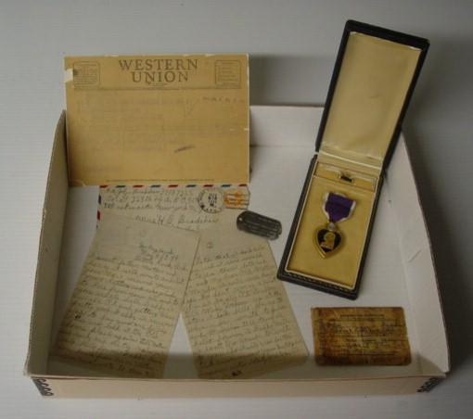
What is a museum? What can you find there? Why are museums important? How do they use artifacts, or objects from the past, to tell stories? These questions are examined as well as learning the role artifacts and exhibits play in preserving history and fulfilling the museum’s mission to honor those whose sacrifice made possible the freedoms we have today. Activities include a scavenger hunt in the museum and solving a mystery using museum artifacts.

The Helen T. Leigh Museum Field Trip Grant application is available through MacArthur Museum of Arkansas Military History and the Arkansas Humanities Council. Deadlines are the first of each month except December. Applicants must contact the museum to schedule their field trip prior to applying for the grant.

Grant Guidelines
- The Helen T. Leigh Museum Field Trip Grant is available to public schools in Arkansas, grades 3 – 12, as well as public community colleges.
- Field trips are available through the MacArthur Museum of Arkansas Military History and must be scheduled prior to submitting the application. All field trips must take place at MacArthur Museum of Arkansas Military History in Little Rock, Arkansas.
- Maximum Award: $500.00*
- Funds may be used for the following:
- Mileage Reimbursement: Up to .58 per roundtrip mile
- Costs Associated With Bus Driver(s) Fee and Use of Bus
- Substitute Teacher(s)
- To schedule a field trip to MacArthur Museum of Arkansas Military History, please contact the museum at 503 E. 9th Street, Little Rock, AR 72202, 501.376.4602 or email the Museum Program Assistant, Shane Lind: alind@littlerock.gov
*If further funding is needed beyond the maximum amount of $500, please provide a justification and a total amount to accompany your application.

The Arkansas Humanities Council
In Partnership With The
MacArthur Museum of Arkansas Military History

Helen T. Leigh Museum Field Trip Grant Application

School:
Name: ________________________________________________________________________
Address:______________________________________________________________________

Principal’s Name: ________________________________________Phone:_________________________
Email: _____________________________________________
Principal’s Signature: ____________________________________________________________________

Teacher:
Name: ________________________________________________________________________
Title/Subject: ___________________________________________________________________
Grade: __________ Number of students: ______________
Date of Scheduled Field Trip: ________________
Email: _____________________________________________
Phone Number: ________________________________

Requested Program:
_____ First Call: American Posters of World War I – Examine the impact of propaganda on how a person or group thinks about people, society and events.

_____ The Little Rock Arsenal – Explore what makes the Arsenal Building historic and what it was like to be a Civil War soldier.

_____ Civil War: The Little Arsenal Crisis – A look at how the first shot of the Civil War were fired here at the Little Rock Arsenal and the history of the Civil War in Arkansas.

_____ History Detective – Explore how museums use artifacts to interpret the past.

Helen T. Leigh Museum Field Trip Grant Application Page 2
In addition to the program you have selected, the following programs and tours are also available upon request. If you would like to add one of these programs or tours to your scheduled visit, please indicate below.

Programs:
_____ Flags of Our Fathers – The meaning and symbolism of the American Flag.
_____ Remember Me - What makes a person a hero? Examines how society commemorates historical figures, such as David O. Dodd.
_____ The Art of War - Utilizes diverse art mediums to explore the humanity in war.
_____ History Explorers Reading Program-The books selected for this reading program will focus on a particular historical military period.
Tours:
_____First Call: American Posters of World War I
_____From Turbulence to Tranquility: The Little Rock Arsenal
_____The Sun Never Sets on the Mighty Jeep: The Jeep during World War II
_____Capital and Conflict: Little Rock and the Civil War
_____By the President in the Name of Congress: Arkansas’s Medal of Honor Recipients
_____Duty, Honor, Country: General Douglas MacArthur

- Provide a brief description of how the programs offered will enhance classroom activities studied. (Please be specific)
________________________________________________________________________________________________________________________________________________________________________________________________________________________________________________________________________________________________

- Provide information as to the humanities scholar and their involvement in the project. (Please attach a Humanities Scholar Participation Agreement Form)
________________________________________________________________________________________________________________________________________________

- Please discuss how the project will be evaluated.
________________________________________________________________________________________________________________________________________________________________________________________________________________________

- Budget

Mileage Reimbursement (Up to .54 per roundtrip mile) $_______________________
Bus Driver(s) Fee $_______________________
Use of Bus(s) Fee $_______________________
Substitute Teacher(s) Fee $_______________________

Total Cost: __________________________

The Helen T Leigh Museum Grant is supported by a generous donation by Mrs. Helen T. Leigh in memory of her husband, Lt. Col. Gilbert Leigh, U. S. Air Force. World War I posters are made available through the Thomas Wilson Clapham Collection donated by the Clapham family in his memory.

